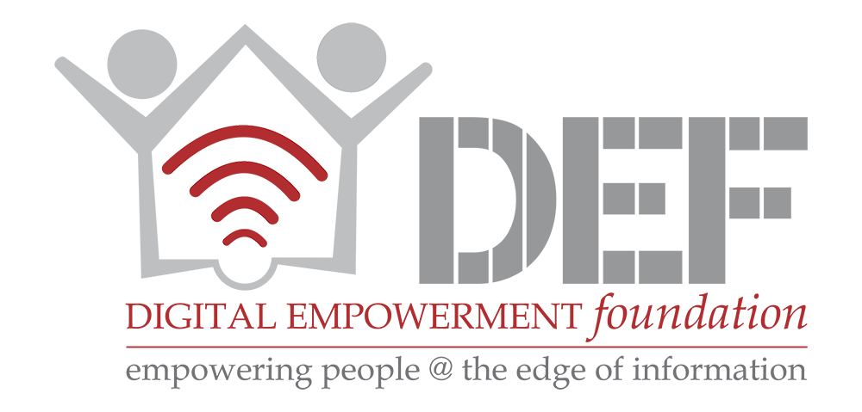

Bot Traffic Report
Imperva

Submission to Mint

By
Digital Empowerment Foundation
Imperva, a company specialising in cyber and data security products released its Bot Traffic Report which seeks to analyse the threats that bots pose to the internet at large. Bots or internet robots are software programs that run automated tasks over the internet. They perform structurally repetitive tasks that are simple, at a much higher rate than a single human. Currently, more traffic on the internet is due to the actions of bots than due to the actions of humans.

Due to the automated nature of bots, there are many uses for them which may be both benign and malicious.
There is a clear split in the number of good and bad bots, with malicious bots accounting for 52% of the bot traffic.

While there are many types of malicious bots, they may be classified into 4 major types:
- Impersonators
- Hacking tools
- Scrapers and
- Spammers
An overwhelming majority of malicious bots are what are known as impersonators; which mimic the behavioural patterns of a human user. There are many methods to counter such bots including the CAPTCHA.

Due to improvements in the artificial intelligence over the past few years, impersonator bots are the only bot type to show any significant growth over the past 3 years.

Small sites are more prone to having a higher share of their overall traffic originating from bots. The overall share of bot traffic on sites reduces as the size of the site increases; finally coming to rest around 52% for the top 100 sites ranked according to Alexa.

